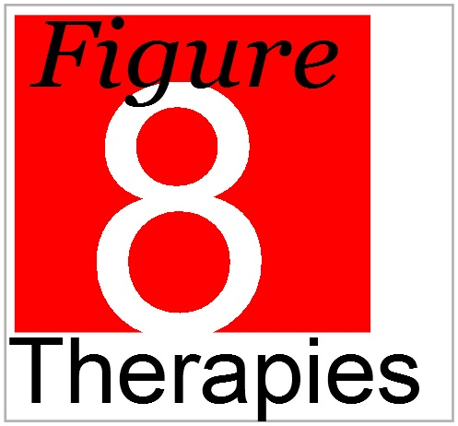

Professional Massage Treatment – a helping hand when you need it! - 0191 483 6688

Jarrow Practice Price List

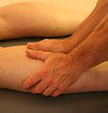
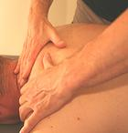
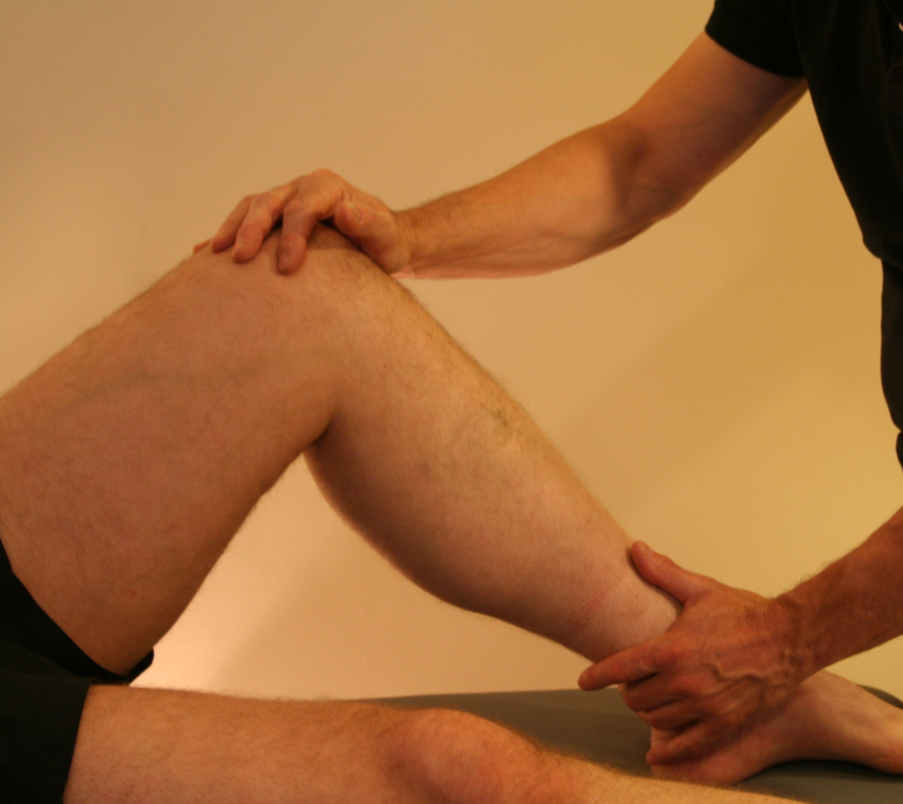

Sports & Remedial Massage:
This type of massage is designed to increase recovery from injury, improve athletic performance and reduce the risk of injury during physical activity. It involves a combination of firm direct pressure to the major muscle groups, trigger point therapy and facilitated stretching to repair damaged tissue and improve muscle function.

Duration | Cost
30 minute treatment | £20.00
45 minute treatment | £28.00
60 minute treatment | £35.00

Please Note: With this type of massage we recommend your first treatment is 45 minutes to allow time for the collection of information on medical history, past injuries and to conduct required physical assessments.

For more info visit www.figure8therapies.co.uk
or visit Facebook


Block Booking Discount

We are now offering a special reduced rate for all clients at the Jarrow Practice when block booking massage sessions.
4 Sessions
Usual Price | £20 x 4 = £80
Special Price | £72
(cost = £18 per session)
6 Sessions
Usual Price | £20 x 6 = £120
Special Price | £96
(cost = £16 per session)
8 Sessions
Usual Price | £20 x 8 = £160
Special Price | £112
(cost = £14 per session)

Please Note: Your Chiropractor can advise you when it is best for you to start your massage sessions.
If you have any massage questions or queries contact
Steve Lovell, our massage therapist on 0751 3923323.

