Jarrow Practice Price List

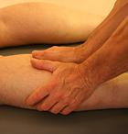
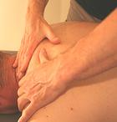
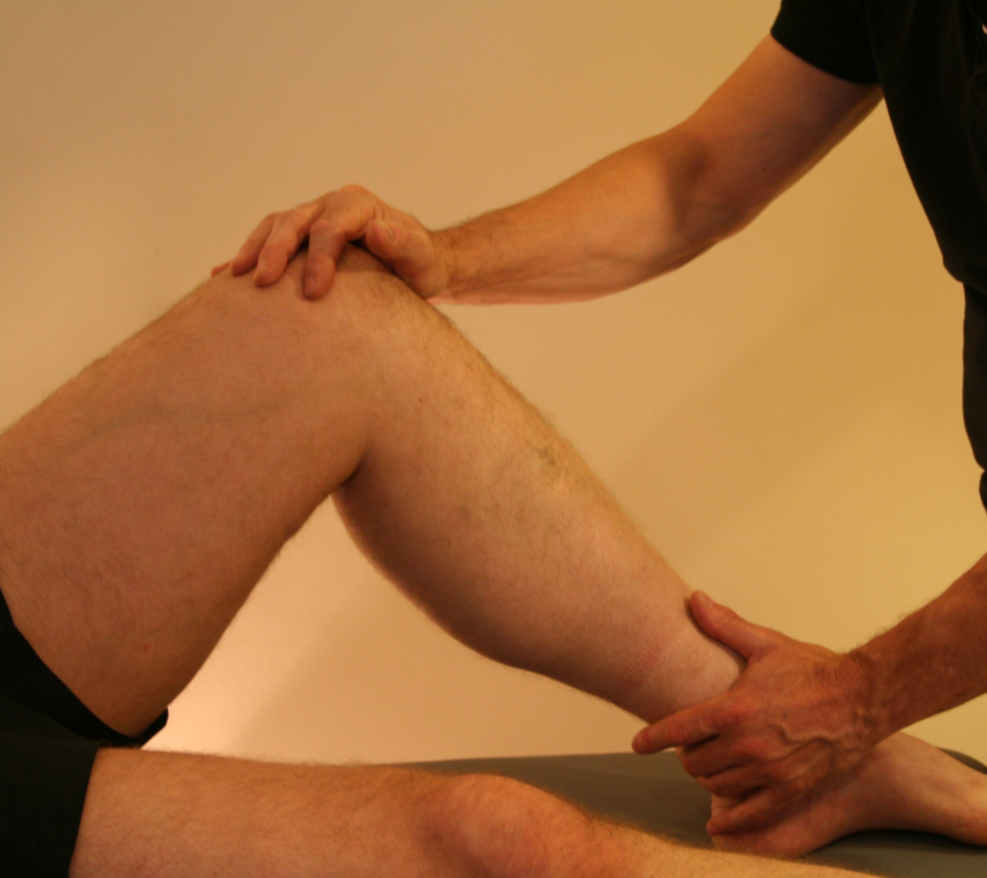

Remedial Massage:
This type of massage sometimes known as medical massage is designed to release muscle tension, increase recovery from injury and treat chronic pain. It is good for everyone, including people with medical conditions, due to its therapeutic approach.

Duration | Cost
30 minute treatment | £25.00
45 minute treatment | £33.00
60 minute treatment | £40.00

Please Note: We recommend that your first treatment is 45 minutes to allow for the collection of information on medical history, past injuries and to conduct required physical assessments.

Block Booking Discount

We are now offering a special reduced rate for all clients at the Jarrow Practice when block booking massage sessions.
4 x 30 minute Sessions
Usual Price | £25 x 4 = £100
Special Price | £88
(cost = £22 per session)
6 x 30 minute Sessions
Usual Price | £25 x 6 = £150
Special Price | £120
(cost = £20 per session)
8 x 30 minute Sessions
Usual Price | £25 x 8 = £200
Special Price | £144
(cost = £18 per session)

If you have any massage questions or queries contact Steve Lovell, our massage therapist on 0751 3923323.

